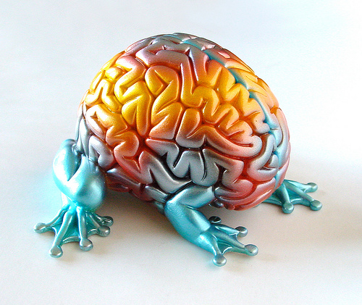

Things Everybody Ought to Know About Concentrating
by sscheper on April 18, 2010
“Music helps me concentrate,” Mike said to me glancing briefly over his shoulder.
Mike was in his room writing a paper for his U.S. History class. On his desk next to his computer sat crunched Red Bulls, empty Gatorade bottles, some extra pocket change and scattered pieces of paper. In the pocket of his sweat pants rested a blaring iPod with a chord that dangled near the floor, almost touching against his Adidas sandals. On his computer sat even more stray objects than his surrounding environment. There must have been twenty browser tabs open. The tabs included political blog news, random Wikipedia entries, Facebook profiles and a Myspace page blasting more music at him. Two notifications with sound popped-up simultaneously in the top-right corner of his screen. One was an email; the other was a tweet. Behind his dozens of browser windows sat a pending music download and a handful of blinking IM’s.
Mike made a shift about every thirty seconds between all of the above. He’d write a little bit for his history paper, check his pending download, reply to his IM’s, and then start all over.
Do you know a person like this? I do. Those were my concentration habits at one point in my life. Yet, I made a series of decisions that resulted in a 180 degree turn. This book is about how to make that 180 degree turn. And this chapter centers on understanding a core component for getting focused: short-term focus (or concentration). We’ll first outline what science teaches us about concentration.

The Science Behind Concentration
In the above account, Mike’s obviously stuck in a routine that many of us may have found ourselves in, yet in the moment we feel it’s almost an impossible routine to get out of. Many fall into this pattern because constantly shifting attention and multitasking eases the pain of doing something you hate in the first place. We mitigate essays and projects with blasts of dopamine delivered through tweets, music and gossip.What science tells us, though, is that not only does multitasking make our work 50% less valuable; it takes 50% longer to finish. Plus, it’s physiologically impossible for the brain to multitask.
When we constantly multitask to get things done, we’re not multitasking, we’re rapidly shifting our attention. And this rapid shifting kills the mind, it waters its effectiveness down significantly. When we follow Mike’s pattern above, the mind shifts through three phases:
- What evidence does the author provide that multitasking is a myth?

Phase 1: Blood Rush Alert
When Mike decides to start writing his History essay, blood rushes to his anterior prefrontal cortex. Within this part of the brain, sits a neurological switchboard. The switchboard alerts the brain that it’s about to shift concentration.

Phase 2: Find and Execute
The alert carries an electrical charge that’s composed of two parts: first, a search query (which is needed to find the correct neurons for executing the task of writing), and second, a command (which tells the appropriate neuron what to do). This process propels Mike into a mental state of writing for his History essay. Your mind literally puts a writing cap on.

Phase 3: Disengagement
While in this state, Mike then hears an email notification. His mind rapidly disengages his current writing state, and then sends blood-flow back to Phase 1, which then leads him to phase 2, and then when he gets distracted again, he’ll find himself at phase 3.
2. Explain in your own words or draw the effects of distractions on our ability to focus.

The process repeats itself sequentially. It doesn’t work simultaneously (i.e. multitasking). The mind shifts rapidly through this phase at a rate of one-tenth of a second. This tells us two important things: it reinforces the case that we must only focus on one thing at a time, and second, it’s critical to master selective attention, which we’ll explore below.

Concentration drives intelligence
Research surfaced recently that revealed the true drivers of intelligence. They asked, “Is intelligence simply the ability to assimilate information and recall upon it whenever needed?” Is intelligence really a measure of memory? If not, than what makes a person intelligent? Amazingly, they found that intelligence is not founded on one’s memory. Instead, intelligence emanates from one’s ability to control their selective attention. It’s their ability to control the three phases above, and where they route their blood-flow to within the prefrontal cortex.
3. According to research what makes a person intelligent?

As you improve in the ability to strategically allocate your attention, your brain also improves. In fact, it rewires itself. As you exercise concentration and selective attention, your mind rewires itself to support your new habits. You get better and better at concentrating when you concentrate. That’s the good news.
4. What happens to your brain as you work to improve your focus?

Now that you know a bit about the science and background of your mind, we’ll explore 8 things that will help you build short-term focus (concentration).

Things Everybody Ought to Know About Concentrating

You can’t start concentrating until you’ve stopped getting distracted
The phrase above is self-explanatory. Yet, it’s amazing how most people look for some crazy, obtuse solution for the reason why they can’t concentrate. They reason, “I just have ADD. I can’t concentrate.” In reality, their situation likens itself to Mike’s situation above.
In the late 80′s, two researchers asked themselves a chicken-egg question. (“What came first the chicken or the egg?”). Their version centers on distraction and boredom. They asked themselves, “What came first, distraction or boredom.” What they found is rather subtle, yet it’s profoundly significant. They found that distraction leads to boredom (not the other way around). This displays that we must cut out distraction in order to get focused; or else, we’ll get bored.
5. When we are distracted and not working at focusing we don’t learn and we become bored! Can you think of a time when this was true for you?

Scientists also found that we can only focus on one thing at once. Nobody does that. We’ve always got something going on in the background of whatever we’re doing. We’ve always got two-dozen tasks on our to-do list. On top of this, we’ve got a handful of projects that we try and finish simultaneously.
The quote below by John Wooden summarizes this quite nicely. Recall upon this daily if you’re having a difficult time breaking away from the ineffective lifestyle.
“Don’t mistake activity for achievement.” – John Wooden
Remember – intelligence comes from focused concentration. Beware of the distractions around you. We’re all human and prone to laziness or becoming an inefficient work-a-holic, but we can choose to focus and work at becoming effective learners.
6. Text Rendering- Underline a sentence, a phrase, and a word in this text that are meaningful to you.

